CHAPTER-8

Network Layer and Internet Layer

8.1 Design Issues
The network layer is responsible for the source-to-destination delivery of a packet, possibly across multiple networks (links). Whereas the data link layer oversees the delivery of the packet between two systems on the same network (links), the network layer ensures that each packet gets from its point of origin to its final destination.

The network layer adds a header that includes the logical addresses of the sender and receiver to the packet corning from the upper layer. If a packet travels through the Internet, we need this addressing system to help distinguish the source and destination. When independent networks or links are connected together to create an internetwork, routers or switches route packets to their final destination. One of the functions of the network layer is to provide a routing mechanism. The services of network layer need to be carefully designed with the following goals in mind:
- The services should be independent of the router technology.
- The transport layer should be shielded from the number, type, and topology of the routers present.
- The network addresses made available to the transport layer should use a uniform numbering plan, even across LANs and WANs.

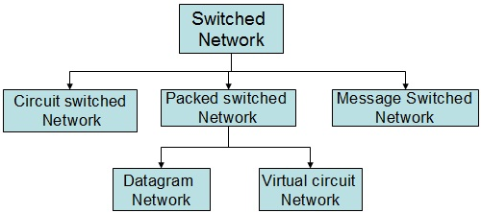
8.2 Switching
A switched network consists of a series of interlinked nodes, called switches. Switches are devices capable of creating temporary connections between two or more devices linked to the switch. In a switched network, some of these nodes are connected to the end system such computer or telephone set. Traditionally, three methods of switching have been important: circuit switching, packet switching, and message switching. The first two are commonly used today. The third has been phased out in general communications but still has networking applications.

- Circuit Switched Network
A circuit-switched network consists of a set of switches connected by physical links. A connection between two stations is a dedicated path made of one or more links. However, each connection uses only one dedicated channel on each link. Each link is normally divided into n channels by using FDM or TDM. The actual communication in a circuit-switched network requires basic three phases:
- Communication setup phase: Before any signals can be transmitted, an end-to-end (station-to-station) circuit must be established. For example, on establishing the connection over PSTN, the connection must be set-up over multiple switching nodes. Based on routing information and measures of availability and perhaps cost, one node selects the link to other node, allocates a free channel (using FDM or TDM) on that link, and sends a message requesting connection to final destination.
- Data transfer phase: Data can now be transmitted from source through the network to destination. The transmission may be analog or digital, depending on the nature of the network.
- Connection termination phase: After some period of data transfer, the connection is terminated, usually by the action of one of the two stations.
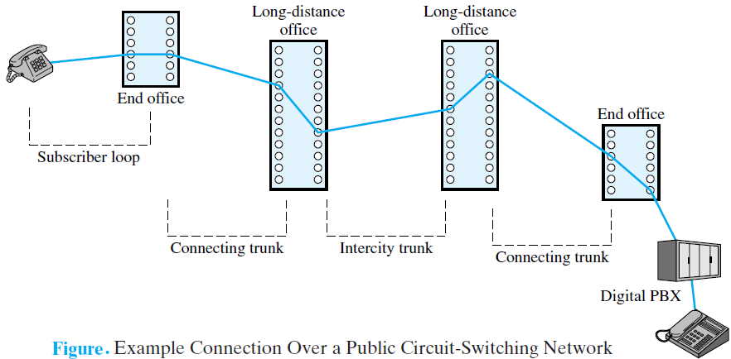

In circuit switching, the resources need to be reserved during the setup phase; the resources remain dedicated for the entire duration of data transfer until the teardown phase. Switching at the physical layer in the traditional telephone network uses the circuit-switching approach.

- Packet Switching network
In data communications, we need to send messages from one end system to another. If the message is going to pass through a packet-switched network, it needs to be divided into packets of fixed or variable size. The size of the packet is determined by the network and the governing protocol. In packet switching, there is no resource allocation for a packet. This means that there is no reserved bandwidth on the links, and there is no scheduled processing time for each packet. Resources are allocated on demand. The allocation is done on a first-come, first-served basis. Each packet contains not only the data but also a header with control information by the help of which the packet is routed on the network. The main difference between the circuit switching and packet switching can be listed as:

- Dedicated transmission path.
- Continuous transmission of data.
- Messages are not stored.
- Call setup delay i.e. negligible transmission delay.
- Busy signal if called party is busy.
- The path is established for entire conversation.
- Electromechanical or computerized switching nodes.
- User is responsible for message loss protection.
- Fixed bandwidth.
- Overload if block call setup.

Circuit switching

- No dedicated transmission path.
- Transmission of packet.
- Packets may be stored until delivered.
- Packet transmission delay.
- Sender may be notified if packet is not delivered.
- Route established for each packet.
- Small switching nodes.
- Network is not responsible for individual packet.
- Dynamic use of bandwidth.
- Overload increases the packet delay but call is established.
Packet Switching

There are two approach of packet switching network: -

- Datagram Packet switching
In a datagram network, each packet is treated independently of all others. Even if a packet is part of a multi-packet transmission, the network treats it as though it existed alone. Packets in this approach are referred to as datagram. Datagram switching is normally done at the network layer.
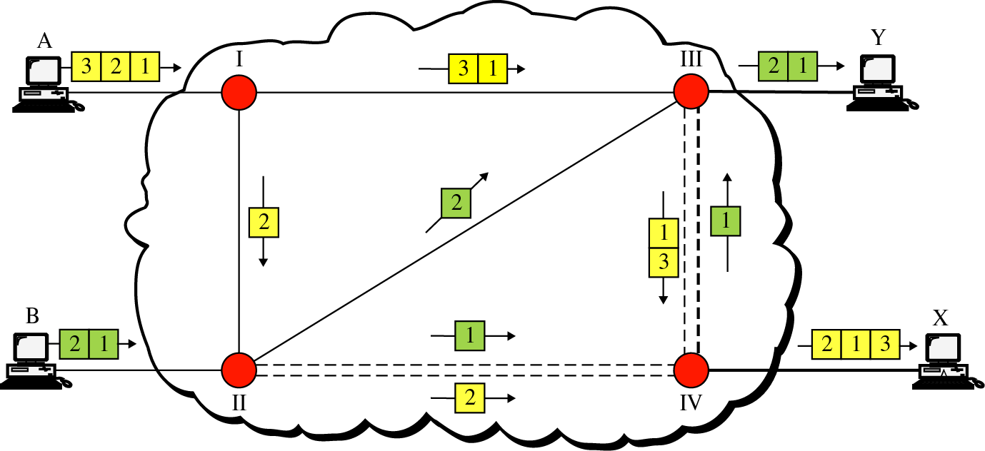
In this example, all four packets (or datagram) belong to the same message, but may travel different paths to reach their destination. This is so because the links may be involved in carrying packets from other sources and do not have the necessary bandwidth available to carry all the packets from A to X. This approach can cause the datagram of a transmission to arrive at their destination out of order with different delays between the packets. Packets may also be lost or dropped because of a lack of resources. In most protocols, it is the responsibility of an upper-layer protocol to reorder the datagram or ask for lost datagram before passing them on to the application.

A switch in a datagram network uses a routing table that is based on the destination address. The destination address in the header of a packet in a datagram network remains the same during the entire journey of the packet. Switching in the Internet is done by using the datagram approach to packet switching at the network layer.

- virtual-circuit network
A virtual-circuit network is a cross between a circuit-switched network and a datagram network. It has some characteristics of both.
- As in a circuit-switched network, there are setup and teardown phases in addition to the data transfer phase.
- Resources can be allocated during the setup phase, as in a circuit-switched network, or on demand, as in a datagram network.
- As in a datagram network, data are packetized and each packet carries an address in the header.
- As in a circuit-switched network, all packets follow the same path established during the connection.
- A virtual-circuit network is normally implemented in the data link layer, while a circuit-switched network is implemented in the physical layer and a datagram network in the network layer.
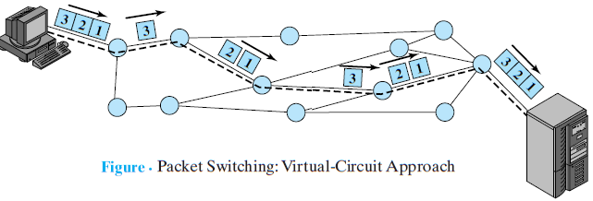

In virtual-circuit switching, all packets belonging to the same source and destination travel the same path; but the packets may arrive at the destination with different delays if resource allocation is on demand. Switching at the data link layer in a switched WAN is normally implemented by using virtual-circuit techniques. The examples of virtual-circuit switching networking are the Frame Relay networks, ATM networks etc.

Comparison of Virtual circuit & datagram Subnet
S.N. | Issues | Datagram Subnet | Virtual-Circuit Subnet
1. | Circuit Setup | Not needed | Required
2. | Addressing | Each packet contains the full source & destination address. | Each packet contains a short virtual-circuit number.
3. | State-information | Router doesn’t hold state information about connections. | Each V.C requires the router table space for connections.
4. | Routing | Each packet is routed independently. | Route chosen when V.C. is setup; all packets following it.
5. | Quality of Service (QOS) | Difficult | Easy if enough resources can be allowed in advance for each VC.
6. | Congestion Control | Difficult | Easy if enough resources can be allowed in advance for each VC.

8.3 Routing
The routers in an internet are responsible for receiving and forwarding packets through the interconnected set of networks. Each router makes routing decision based on knowledge of the topology and traffic/delay conditions of the internet. The routing algorithm is that part of the network layer software responsible for deciding which incoming packet should be transmitted on which output line. Regardless of whether routes are chosen independently for each packet sent or only when new connections are established, certain properties are desirable in a routing algorithm: correctness, simplicity, robustness, stability, fairness, and efficiency.

Routing protocols have been created in response to the demand for dynamic routing tables. A routing protocol is a combination of rules and procedures that let routers in the internet inform each other of changes. It allows routers to share whatever they know about the internet or their neighborhood. The routing protocols also include procedures for combining information received from other routers.

A router should receive a packet from a network and passes it to another network in more cost effective manner. The cost is evaluated according to the time passes, distance travels, required delay, system throughput, type of services etc. Metric is one approach to assign a cost for passing through a network. However, the metric assigned to each network depends on the type of protocol such as:
- Routing Information Protocol (RIP) treats all networks as equals. The cost of passing through a network is the same; it is one hop count. So if a packet passes through 10 networks to reach the destination, the total cost is 10 hop counts.

- Open Shortest Path First (OSPF) allows the administrator to assign a cost for passing through a network based on the type of service required. A route through a network can have different costs (metrics). For example, if maximum throughput is the desired type of service, a satellite link has a lower metric than a fiber-optic line. On the other hand, if minimum delay is the desired type of service, a fiber-optic line has a lower metric than a satellite link.

- In the Border Gateway Protocol (BGP), the criterion is the policy, which can be set by the administrator. The policy defines what paths should be chosen.

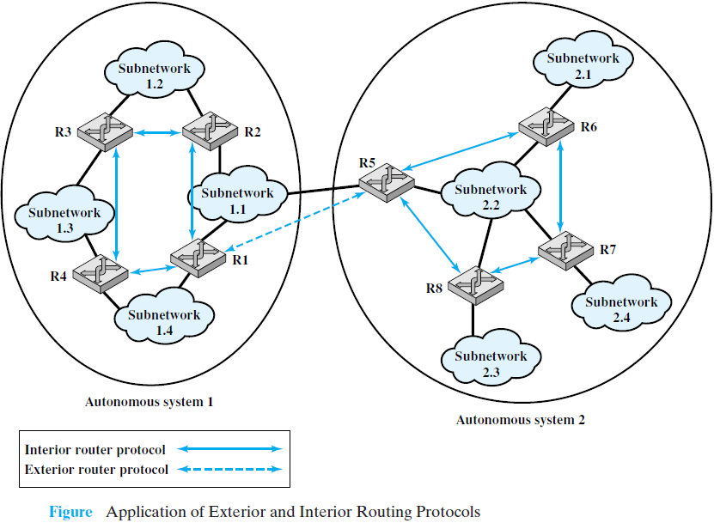
Today, an internet can be so large that one routing protocol cannot handle the task of updating the routing tables of all routers. For this reason, an internet is divided into autonomous systems. An autonomous system (AS) is a group of networks and routers under the authority of a single administration. Routing inside an autonomous system is referred to as intra-domain routing. Routing between autonomous systems is referred to as inter-domain routing. Each autonomous system can choose one or more intra-domain routing protocols to handle routing inside the autonomous system. However, only one inter-domain routing protocol handles routing between autonomous systems.

The routing algorithm can be grouped into two categories as shown in figure. Routing Information Protocol (RIP) is an implementation of the distance vector protocol. Open Shortest Path First (OSPF) is an implementation of the link state protocol. Border Gateway Protocol (BGP) is an implementation of the path vector protocol.

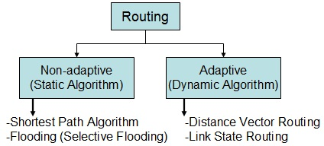
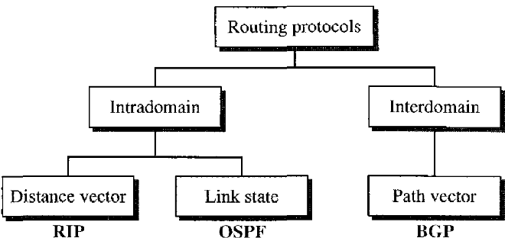

- Non-adaptive Routing
In this static routing algorithm, the route from one node to every other node is computed in advance. If the network topology is change, the routing table must be updated manually. It can further categories as: flooding & shortest path routing algorithm. There are many shortest paths routing algorithm, among them, the Dijkstra’s algorithm is considered as more efficient method for shortest path calculation.

Dijkstra's algorithm
Dijkstra's algorithm (named after it’s discover, E.W. Dijkstra) solves the problem of finding the shortest path from a point in a graph (the source) to a destination. It turns out that one can find the shortest paths from a given source to all points in a graph in the same time; hence this problem is sometimes called the single-source shortest paths problem.

Thus, Dijkstra's algorithm, is a graph search algorithm that solves the single-source shortest path problem for a graph with nonnegative edge path costs (or weights), producing a shortest path tree. This algorithm is often used in routing and as a subroutine in other graph algorithms.

Algorithm
Let the node at which we are starting be called the initial node. Dijkstra's algorithm will assign some initial distance values and will try to improve them step by step.
- Assign to every node a distance value: set it to zero for our initial node and to infinity for all other nodes.
- Mark all nodes as unvisited. Set initial node as current.
- For current node, consider all its unvisited neighbors and calculate their tentative distance. If this distance is less than the previously recorded distance, overwrite the distance.
- When we are done considering all neighbors of the current node, mark it as visited. A visited node will not be checked ever again; its distance recorded now is final and minimal.
- If all nodes have been visited, finish. Otherwise, set the unvisited node with the smallest distance (from the initial node, considering all nodes in graph) as the next "current node" and continue from step 3.

Initial graph for Dijkstra Algorithm Final Graph of Dijkstra Algorithm
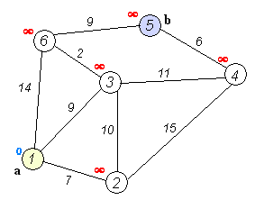
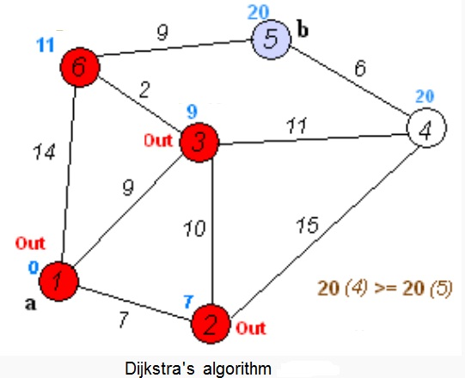

Flow Based Routing Algorithm (Flooding)
When a routing algorithm is implemented, each router must make decisions based on local knowledge, not the complete picture of the network. A simple local technique is flooding, in which every incoming packet is sent out on every outgoing line except the one it arrived on. Flooding always chooses the shortest path and a shorter delay because it chooses every possible path in parallel.

Flooding obviously generates vast numbers of duplicate packets, in fact, an infinite number unless some measures are taken to damp the process. One such measure is to have a hop counter contained in the header of each packet that is decremented at each hop, with the packet being discarded when the counter reaches zero. Ideally, the hop counter should be initialized to the length of the path from source to destination. If the sender does not know how long the path is, it can initialize the counter to the worst case, namely, the full diameter of the network.

Flooding with a hop count can produce an exponential number of duplicate packets as the hop count grows and routers duplicate packets they have seen before. A better technique for damming the flood is to have routers keep track of which packets have been flooded, to avoid sending them out a second time. One way to achieve this goal is to have the source router put a sequence number in each packet it receives from its hosts. Each router then needs a list per source router telling which sequence numbers originating at that source have already been seen. If an incoming packet is on the list, it is not flooded.

Flooding is not practical for sending most packets, but it is effective for broadcasting information. In wireless networks, all messages transmitted by a station can be received by all other stations within its radio range. Also, flooding is tremendously robust so used in a military network.

- Adaptive Routing Algorithm
In this dynamic technique, the routing table is updated dynamically when there is a change in the network. They get the routing information from their adjacent router. It is further divided as:
          - Distance vector routing algorithm
In distance vector routing, the least-cost route between any two nodes is the route with minimum distance. In this protocol, as the name implies, each node maintains a vector (table) of minimum distances to every node. The table at each node also guides the packets to the desired node by showing the next stop in the route (next-hop routing). In this algorithm, each router periodically shares its routing information about the entire network only with its neighbors. The three key points to understand it are:
            - Share the gained knowledge about the entire network
            - Share information only to their neighbors.
            - Share information in regular interval and when there is a change.
            - It was the original ARPANET routing algorithm and was also used in the Internet under the name Routing Information Protocol (RIP).

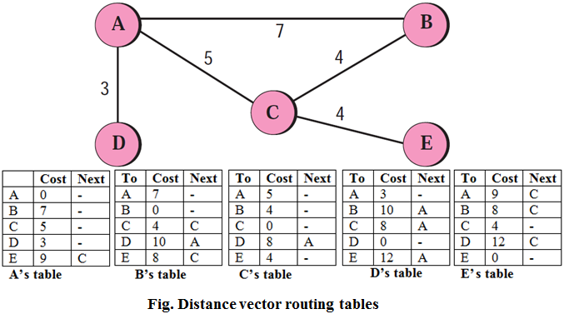
In distance vector routing, each router maintains a routing table indexed by, and containing one entry for each router in the network. This entry has two parts: the preferred outgoing line to use for that destination and an estimate of the distance to that destination. The distance might be measured as the number of hops or using another metric, as we discussed for computing shortest paths.

Initially the distance of non-neighboring nodes is set to infinite and on each hop they are updated dynamically. The router is assumed to know the ‘‘distance’’ to each of its neighbors. If the metric is hops, the distance is just one hop. If the metric is propagation delay, the router can measure it directly with special ECHO packets that the receiver just timestamps and sends back as fast as it can.

          - Link State Routing Algorithm
This is the extension on distance vector routing algorithm. The main three key points for this algorithm are:
- Share the knowledge of neighbors only.
- Share information to all routers present on the network.
- The information shares only when there is a change on the network.
- The second generation routing algorithm also used for ARPANET. Variants of link state routing called Intermediate System-Intermediate System (IS-IS) and Open Shortest Path First (OSPF) are the routing algorithms that are most widely used inside large networks and the Internet today.

8.4 Spanning Tree Routing
A graph G = (V, E) consists of V, a non-empty set of vertices or nodes and E, a set of edges. In graph, there may be multiple edges connected to multiple vertices forming many circuit or cycle. If all the possible nodes of a graph are connected, it is called connected graph, otherwise it is disconnected graph. If we assign the weighted value on the basis of time, distance, computation complexity etc. it is called weighted graph. Besides that, a tree is a connected graph with no any cycles or circuits. A collection of trees is called a forest.

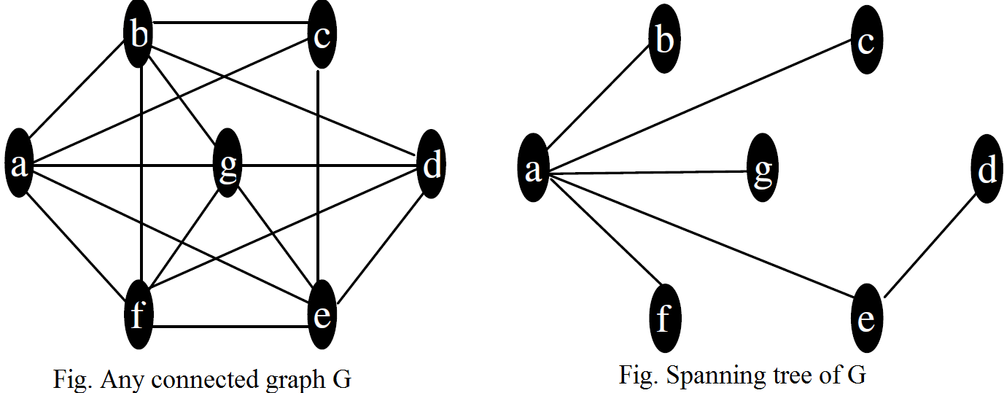
A tree T is a spanning tree of connected graph G, if T is a sub-graph of G that contains all of the vertices of G. This is true conversely too. A minimum spanning tree in a connected weighted graph is a spanning tree that has the smallest possible sum of weights of its edges.

Since the vertices of G are barely hanging together in a spanning tree, it is a sort of skeleton of original graph G, so sometimes the spanning tree is also referred to as a skeleton or scaffolding. The spanning tree is defined only for a connected graph because a tree is always connected. Also, in converse manner, a graph G has a spanning tree if and only if G is connected.

Finding a spanning tree of a connected graph G is simple. If G has no cycle, it is its own spanning tree. If G has a cycle, delete that edge which form the cycle and repeat that process if there is other cycle on the connected graph.

Kruskal’s Algorithm for Minimum Spanning Tree
Kruskal’s algorithm is a procedure for producing a minimum spanning tree in a weighted graph that successively adds edges of least weight such that no edges produces a simple circuit or cycle when it is added. The basic steps for this algorithm can be listed as:
- List the size of all the edges
- Draw the tree in increasing order from the least value
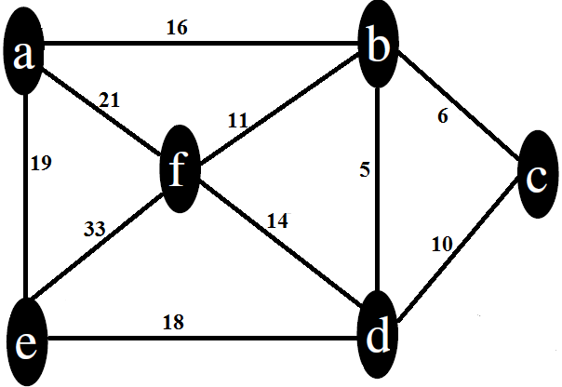
- Discard the edge which form the cycle

For example: The minimum spanning tree of the given connected graph can be determined using the Kruskal’s algorithm as:
Step-1: Listing the size of all the edges of graph
(A, B) = 16 (C, D) = 10
(B, C) = 6 (D, F) = 14
(B, D) = 5 (D, E) = 18
(B, F) = 11 (E, F) = 33
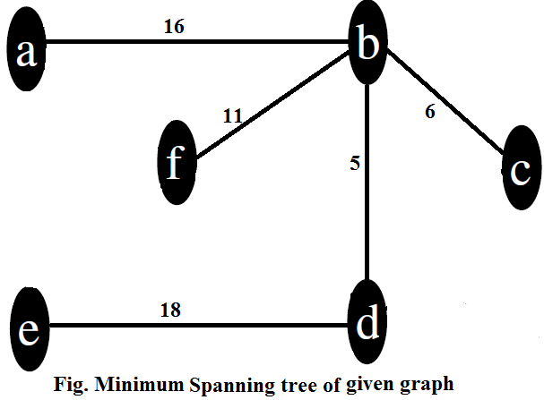
(A, F) = 21 (A, E) = 19
Step-2: Drawing the minimum spanning tree with increasing order of weighted value by discarding the edges which form cycle

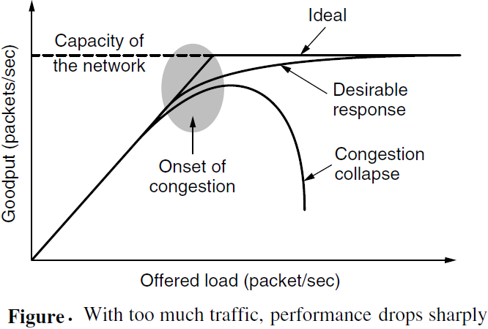
8.5 Congestion Control
An important issue in a packet-switched network is congestion. Congestion in a network may occur if the load on the network-the number of packets sent to the network-is greater than the capacity of the network-the number of packets a network can handle. Congestion control refers to the mechanisms and techniques to control the congestion and keep the load below the capacity.

Congestion control and quality of service are two issues so closely bound together that improving one means improving the other and ignoring one usually means ignoring the other. Most techniques to prevent or eliminate congestion also improve the quality of service in a network.

It is worth pointing out the difference between congestion control and flow control, as the relationship is a very subtle one. Congestion control has to do with making sure the network is able to carry the offered traffic. It is a global issue, involving the behavior of all the hosts and routers. Flow control, in contrast, relates to the traffic between a particular sender and a particular receiver. Its job is to make sure that a fast sender cannot continually transmit data faster than the receiver is able to absorb it.

Congestion control refers to techniques and mechanisms that can either prevent congestion, before it happens, or remove congestion, after it has happened. In general, we can divide congestion control mechanisms into two broad categories: open-loop congestion control (prevention) and closed-loop congestion control (removal).
- Open Loop: Retransmission policy, Window policy, Acknowledgment policy, Discarding policy, and Admission policy
- Close Loop: Back pressure, Choke packet, Implicit signaling, and Explicit signaling

8.6 Traffic Shaping
Traffic shaping is a mechanism to control the amount and the rate of the traffic sent to the network. It smooths out the traffic on the server side, rather than on the client side. Two techniques can shape traffic: leaky bucket and token bucket. A leaky bucket algorithm shapes bursty traffic into fixed-rate traffic by averaging the data rate.

- The Leaky Bucket Algorithm
If a bucket has a small hole at the bottom, the water leaks from the bucket at a constant rate as long as there is water in the bucket. The rate at which the water leaks does not depend on the rate at which the water is input to the bucket unless the bucket is empty. The input rate can vary, but the output rate remains constant. Similarly, in networking, a technique called leaky bucket can smooth out bursty traffic. Bursty chunks are stored in the bucket and sent out at an average rate. It is implemented as a single-server queue with constant service time. If the bucket (buffer) overflows then packets are discarded.

A simple leaky bucket implementation is shown in following figure. A FIFO queue holds the packets. If the traffic consists of fixed-size packets (e.g., cells in ATM networks), the process removes a fixed number of packets from the queue at each tick of the clock. If the traffic consists of variable-length packets, the fixed output rate must be based on the number of bytes or bits. E.g. 1024 bytes per tick will allow one 1024-byte packet or two 512-byte packets or four 256-byte packets on 1 tick.
The following is an algorithm for variable-length packets:
- Initialize a counter to n at the tick of the clock.
- If n is greater than the size of the packet, send the packet and decrement the counter by the packet size. Repeat this step until n is smaller than the packet size.
- Reset the counter and go to step 1.
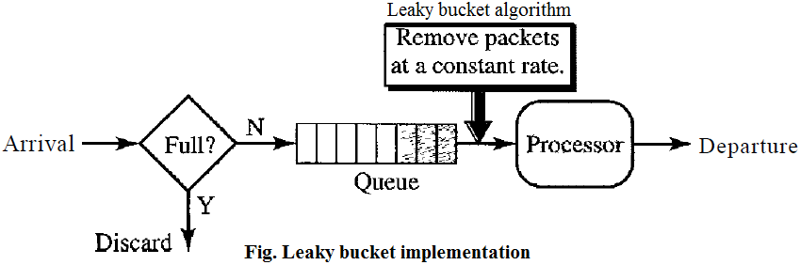

- Token Bucket Algorithm
The leaky bucket is very restrictive. It does not credit an idle host. For example, if a host is not sending for a while, its bucket becomes empty. Now if the host has bursty data, the leaky bucket allows only an average rate. The time when the host was idle is not taken into account. On the other hand, the token bucket algorithm allows idle hosts to accumulate credit for the future in the form of tokens. The token bucket can easily be implemented with a counter. The token is initialized to zero. Each time a token is added, the counter is incremented by 1. Each time a unit of data is sent, the counter is decremented by 1. When the counter is zero, the host cannot send data.
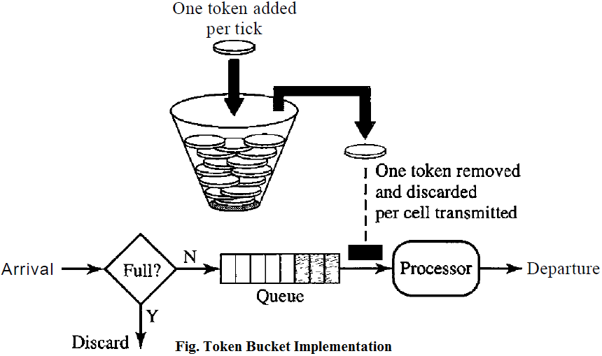

Leaky Bucket vs Token Bucket
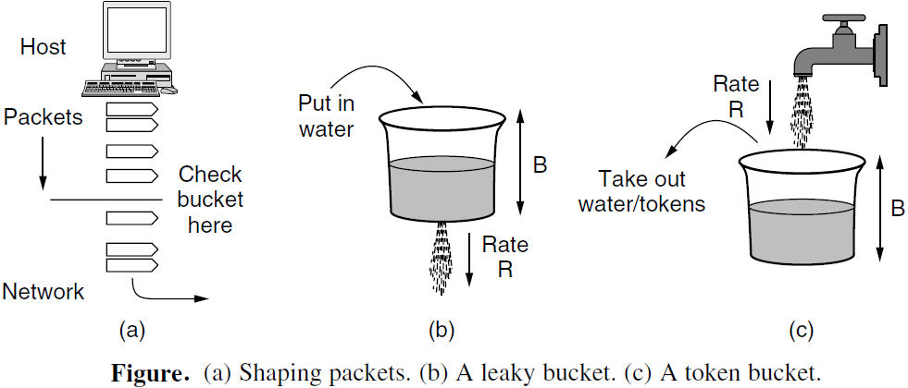
- LB discards packets; TB does not.
- With TB, a packet can only be transmitted if there are enough tokens to cover its length in bytes.
- LB sends packets at an average rate. TB allows for large bursts to be sent faster by speeding up the output.
- TB allows saving up tokens (permissions) to send large bursts. LB does not allow saving.

